VICTORIA’S FIRST “AIR WOMAN” A collaboration by Secretary, Gary Matthews, with Penny Harris Jennings, research officer at the Berwick Pakenham Historical Society
We begin our story of pioneering Ex-Student, Kitty Bloomfield, by briefly jumping forward to this reflective article from the “Melbourne Herald” of 6 July 1937:
“Ten years ago, people in Victoria were beginning to look into the sky at the plane. Essendon Aerodrome was little more than a paddock— a paddock with an entirely male population.
Then the air attracted a woman. Miss Kitty Bloomfield, of Charnwood Grove St.Kilda, young and level-headed, decided it might be nice to fly. She went out to Melbourne's plane centre; she interviewed officials connected with the Victorian. Aero Club and started tuition which made her not long after, the State's first air woman”.[This was on 15 May 1929]. “After finishing her qualifying flight she demonstrated her ability by doing some ‘stunt’ flying.
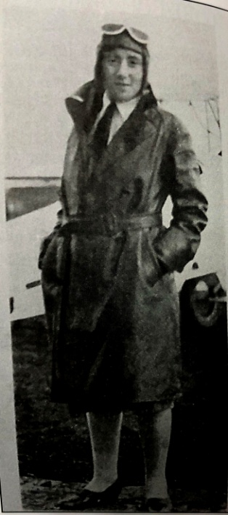
............... “Then for years she let her licence lapse. But the other day she motored into the aerodrome precincts again, asked to be introduced to the instructor, and announced that she wanted to take up her favorite hobby once again.”
Up until now, this has been the main item that set Kitty apart, not only in our State, but certainly in the sweep of the last 100 years of DHS; however, further digging has revealed a great deal more about her. Katie (or Kitty as she became known) Bloomfield , was born at “Myrniong”, Private Hospital, Ascot Vale on 31 December 1904.* Her father, William Henry Rothwell Bloomfield, had been a quite successful public works contractor, constructing country railways, and portion of the Kooweerup Main Drain. In 1893 the family moved from Ascot Vale, and after stints at farming in both Garfield, and five years later, at Pakenham, he later became a General Agent, and active member of the community, until his untimely death, in 1917, aged 53. Her mother, Catherine, died in 1925, when Kitty was 20. * [Although family had moved from Ascot Vale in 1893, Mrs Bloomfield obviously returned there for the birth.(She had two older brothers and two sisters]

The very first we learn of Kitty, is as a nine year old, while she was at Pakenham Primary School, when mentioned at a “Skating Carnival”, held at the Pakenham Mechanics Institute, where she is described as the ‘Japanese Girl’, in a Fancy Dress competition. She is regularly mentioned among prise-winners at the ‘Annual Show’, for the standard of her schoolwork, most notably in 1919, while in grade 8, for her handwriting and a collection of freehand drawings, depicting none other than “The Use Of Aeroplanes”.
Kitty began at DHS in Form D (Form 3, or now Year 9) in 1920. At the end of 1922, she is awarded a “Non Resident Scholarship”, at Melbourne University, and State Teaching Scholarship. However, she does not enter university until 1924, so must have remained at DHS for the “Leaving Honours” (later Matriculation) year. She graduated from Melbourne University in 1927, with a Bachelor of Arts, (Hons), having resided at Janet Clarke Hall, Trinity College. It is noted by Mr Langford, in his 1927 report, that she was the first DHS student to graduate from University.
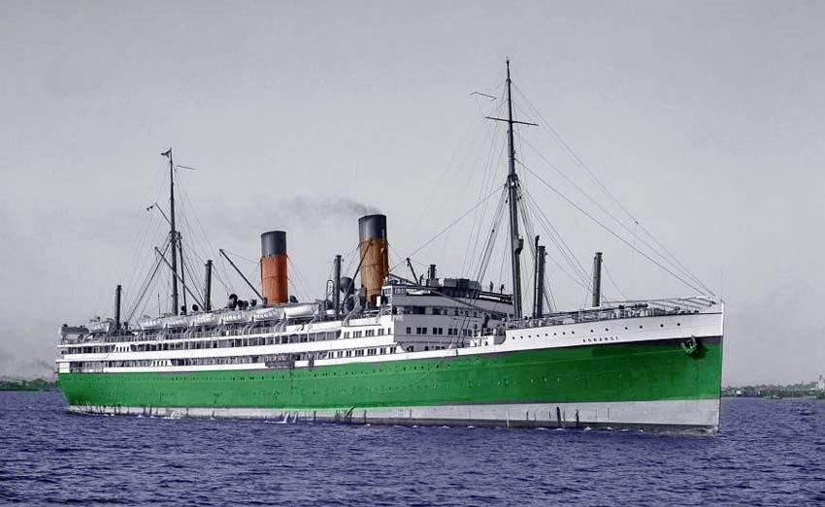
There is mention of her in the August 12, 1926 edition of the Melbourne paper, “Table talk”, among the hostesses at a reception for Janet Clarke Hall students at Melba Hall, Trinity College,“ .... wearing a Tecoma Red brocade gown.”.

On 27 August 1927, Kitty embarked on the first of what were to be many overseas journeys, travelling by “The Oarangi” [one of most luxurious ships of its day] to Seattle, in the USA, and then presumably by train to Boston, where she had enrolled for a post-graduate economics course at Radcliffe College, Harvard. [Clearly she was not only a more than capable student, but also somewhat better placed financially than the average, following her mother’s death in 1925.]
The course was apparently not to her liking though, as, on 19 April 1928, she embarks from New York, together with a girlfriend, bound for Rio de Janeiro. While in the USA, she met pioneer aviator, Charles Lindbergh, who had completed the first solo trans-Atlantic flight, the year before. This was the main inspiration for her wanting to fly herself.
On returning to Australia, Kitty becomes employed at the Shell Oil Company in Spring St Melbourne, as a publicity officer. She opted for this company, thinking it would be likely to advance the cause of the emerging aviation industry. She is again included in “Table Talk”, in August 1929: “Seldom has the St. Kilda Town Hall been more beautifully or elaborately decorated than it was last Tuesday evening, when General Motors held their third annual charity hall. This year the proceeds were devoted to the funds of the Homoeopathic Hospital....... Miss Kitty Bloomfield, who took part in the effective Shell tableau.”
Kitty, who had won a “Blue” for hockey while at university, was included among members of the organising committee for an All Australian Hockey Tournament in August 1935.
From 1931-1936, she is living at 24 Charnworth Cres, St Kilda West, occupation Publicity Agent,
OFF TODAY to "The Alice” This heading appeared in ‘The Adelaide News’ Tuesday 24 March 1936.
“Two eager travellers joined the East-West express today at the Adelaide Railway Station on the first stage of their trip to Alice Springs. They were Miss E. Casely, of Cross roads, Malvern, and a Melbourne friend, Miss Kitty Bloomfield. Miss Bloomfield has travelled a good deal out of Australia, but this is her first visit to the interior. She has been staying .with Miss Casely for a few days. The two will leave the East-West at Quorn, and go on in the little Commonwealth train to Hawker. Here they will spend, a day or so, for they have planned a trip to Wilpena Pound, 35 miles out of Hawker.” In the electoral roll of 1937, Kitty is residing at 43 Spring Street, Melbourne,* still with the Shell Company. * [This would have placed her residence very close to her place of work.]

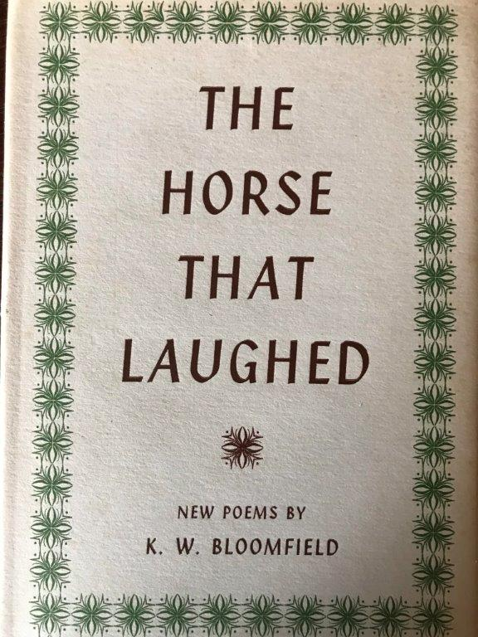
In the Melbourne Argus of 23 July 1938, reporting on a visiting ladies hockey team from the UK, Kitty is mentioned among those who billeted members of the team. On 2 January 1939, she is again off to the UK by ship. This time on ‘The Monterey’, travelling with a Katharine Ballantyne, who comes from “Myrniong”, the place where Kitty was born. Kitty is listed as single, aged 34, and oddly, as a “Student”. Katharine is aged 44, married, and a Journalist.
Moving on, by 1943, [and this is yet another surprise] she is residing at 73 Ringwood Street, Ringwood, and a Medical Student! It is officially recorded in the Government Gazette that she obtained the qualification as GP in Melbourne, in 1944. Also residing at the Ringwood address is Gladys Noake, who arrived from the UK in early 1951.
By 1953, Kate [as she is now more commonly known] is shown as previously living at Folke Rector, Sherborne, Dorset, UK, occupation Medical Practitioner, when she is departing London on ‘The Orcades’ on 28 October of that year. By 1963, she is residing, at 1 Earle Street, Surrey Hills, [the house her sister Jessie and husband had vacated] where she is again listed as a Medical Practitioner. Also residing at that address is teacher, Gladys Noake. It is also in 1963 that she has a book of Australian poetry published.
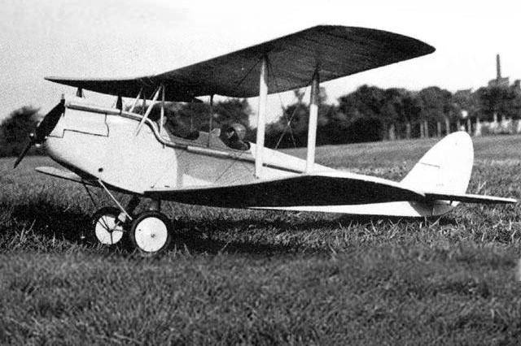
Here are a few lines from one, that capture something of the thrill and adventure she obviously felt in flying in an open cockpit bi-plane.
“Now with full throttle under clammy hands,
A 1925 Cirrus Moth plane, similar to the one in which Kitty obtained her licence.
We raced across that dewy field
Bounced to the sky, praying no eye could see
Our shaky pas-de-deux with gravity.”

1968 – 1993, Kate then residing 46 Maine Street, Tootgarook, occupation Medical Practitioner/ Lecturer/ Retired, and residing with partner, Gladys Eva Noake. Original House still exists.

Kate died on 23 April 1993, aged 88. Her ashes are interred at the Mornington Cemetery. This was a year after her long standing friend and partner, Gladys Noake. This was truly a remarkable woman.

