Dandenong High School Class of ’63, 60-Year Reunion
Saturday 2 September 2023

Seventeen members of the former DHS Class of 1963 (those who commenced in 1958 or joined the cohort later and had they gone on to Form 6, would have completed their secondary schooling in 1963) gathered in the wonderful library at the current Dandenong High School to renew acquaintances and reminisce about times then and since.

Those able to attend were: Shirley Watts (Adams), Robert Bluer, Bernard Bolch, Ross Fotheringham, Noel Goldsmith, Bill Hall, Sandra Giles (Johnston), Robert Jolly, Yvonne Elliott (Kirkham), Deirdre Tolmer (Litchfield), John Martin, Bill Norfolk, Faye Chandley (Pyke), Peter Smith, Leonie Goldsmith (Smithies), Rosalind Terry and Terry Tovey.

DHS Ex-Students’ Association committee members assisted with the set up and their president Greta Jungwirth (de Vries) and Bill Norfolk welcomed all and thanked them for joining us on the day. We then sang a couple of the old school songs, “Faber QuisqueFortunae” with some of the usual poor taste word inserts (“Work stonkers all!”) in the chorus and at the suggestion and urging of Terry Tovey, John Menadue and John Robertson’s song, “We Shall Be Strong”, with its challenging high notes in the chorus. Not easy for our aging larynxes.

With Greta struggling valiantly to “herd cats” we then set off, guided by former teacher and current DHSESA Secretary, Ros Sloan, on a tour of both what remains of the old school and the amazing additions, a lift, the library and learning resource centre, one of the seven House buildings, the cafeteria, science and domestic science block. All eye-opening and a wonder to behold compared with the old science rooms (Rooms 4 and 7 (Bob Baines home)), library and House meeting rooms of old and a stark comparison with the unsheltered lunchtime seating around the original oval and the James Street shop, sole source of lunches for those who didn’t bring theirs from home.

We then enjoyed a slap-up afternoon tea with sandwiches, cakes, sweetmeats and drinks provided by the DHSESA in one of the remaining class rooms (Room 8, I seem to remember) on the upper level of the old building, adjacent to the former Room 9, famous for Mr Rich’s maths lessons (Nn-oou-ww!), which has been allocated to the DHSESA for the wonderful and comprehensive School Archive they’ve established and maintain. The day concluded with more reminiscing, remembering and enjoying the trip back 60 plus years to our time at the school in this DHSESA Archive.

Other Class of ‘63ers whom we were able to contact, but who were unable to attend included Pam Thorn (Smith / Balgue), Marlene Marchant (Bell), Jane Robino (Blanchard), Christine Brown, Geoff Hillard, Helen Gregg (Hoskings), Rodney James, Lesley Chown (Jones), Shirley Cox (Mayers), Val Potts (Moran), Heather Rolls (Patchell), Trish Cogley (Patricia Pegg), John Powell, Margaret Murray (Sereda / Remington), Val Wheeler (Smith), Peter Stocks and his wife Eva Stocks (Havel), Sue Nutting (Trembath), Karin van der Plight and Lyle Wight and his partner Ann Taylor.

We became aware of a number who’d departed this mortal coil, one before, the rest since the 1993, 30-Year Reunion. These are: Ken Allison, Ian Elso, Bruce Forsythe(??), Barry (Wes) Hall, Martin Hallet, Lorraine Murphy (Hayden), Norman Lee, Ekke Martini, Lorraine Reeve (McLeod), Laurel Nethercott, Sergei Sereda and John Wallis.

Our one big disappointment on the day is that we were not sufficiently organised to assemble all of those attending for a group photograph, along the lines of those taken at the 30-Year Reunion, held on 4 December 1993. Never-the-less, some of us did manage some photographs on the day and a collectionof these is included below.

Some 120 of us must have commenced at DHS in 1958, many others joining the cohort as the six years to 1963 passed. As was the case for 1958 Form 2’s,there were five, Form 1’s in 1958, with Forms 2D, 2E and 1E, being girls-only classes, focussed on Commercial and Domestic Arts subjects. The school’s total enrolments in 1958 were approximately 530 girls and 330 boys. The numbers of girls enrolled at DHS significantly exceeded the numbers of boys enrolled, from mid-way through 1933, annually over the next 30 years, until mid-way through 1963.

Form Captains and Vice Captains in 1958 as recorded in “The Gate” of 1958 were:
- Form 1A, Deirdre Morton and Geoff Hillard; BerendinaOldenburger and Sergei Sereda;
- Form 1B, Jacqueline Robert and Malcolm Douglas; Kathryn Smith and Colin Marshal (??);
- Form 1C, Beverly Furlong and Bob Stewart; Brigitte Witt and Colin Marshal (??);
- Form 1 D, Judith Dreverman and Ken Whitehead; Robyn Rennie and Ken Dawson;
- Form 1E, Lorraine McLeod and Judith Alfred.

According to Len Cooke’s 1964 Annual Report (his last as Headmaster) those who Matriculated in 1963 were: Anna Bonk, Lorraine Hewat, Deirdre Litchfield, Valma Lucas, Georgina Phillips, Leonie Smithies and Diane Winberg; Bernard Bolch, Ross Fotheringham, Noel Goldsmith, Robert Jolly, R McLaughlan, Ekke Martini, Michael Pass and David Price; not mentioned unaccountably in the report, except as Matriculation Honours recipients, but who also were known, or believed to have Matriculated in 1963 were, G Baxter, Robert Bluer, Michael Cole, Geoff Cox, Ian Clark, Helen Coram, Linda Dunning, Bill Hall, Martin Hallet, Trevor Kerr, Ekke Martini, GiesjeMeerman, Bill Norfolk (Compensatory Pass), Len O’Brien, John Powell, Kerry Ryan, Sergei Sereda, Peter Stocks, Terry Tovey and John Wallis.

Even at the time of the December 1993, 30-Year Reunion, the class had scatteredfrom their recorded addresses while at school, to Canberra and the ACT, New South Wales, Queensland, South Australia, Tasmania, the Northern Territory, Western Australia and regional Victoria. Since then, some have continued to wander “Hell West and Crooked” and others have returned to settle back in Victoria again, in later years.

The Class of 1963, Souvenir Directory, produced by Bernard Bolch, from his and Bill Norfolk’s details of contact information (addresses while at school, later home addresses, land-line telephone and facsimile numbers – no email addresses or mobile phone numbers), careers, movements and families, since completing their secondary education in December 1963, listed 135 probable members of the DHS Class of ’63 cohort and at least two who were not members. At that time, at least one was widowed, more have become widows, or widower’s since and others have married and/or partnered several times in the past 60 years.

Bernard Bolch went to great lengths to identify other happenings that occurred in 1963, these included:
- Victorian Banks adopted a five-day week (no Saturday banking any more);
- Premier Nikita Khrushchevannounced a 100 megaton Nuclear Bomb, that would kill 800 million;
- Dr Gilbert Bogle and Mrs Margaret Chandler died in bizarre circumstances;
- First test flights of the Boeing 727 took place and the Profumo affair occurred;
- Harold Wilson was named the new leader of the British Labour Party;
- An obscure British Pop Group called the Beatles recorded its first LP “Please Please Me”;
- Dr Martin Luther King was arrested leading a civil rights march in Alabama;
- There were riots in Teheran after the arrest of Moslem leader, Khoumeini;
- Pan Am ordered the Concorde and Australia decided to buy 24, F-111 swing wing bombers;
- The Federal Government thought “Royal” would be a good name for the forthcoming unit of decimal currency;
- UK Pharmaceutical Companies began to market oral contraceptives;
- Pope John XXIII died and Pope Paul VI was elected to lead the Roman Catholic Church;
- Buddhist monks in South Vietnam self-immolated in protest at the mainly Catholic Ngo Dinh Diem government;
- The Ord River project was opened, Comalco started bauxite mining at Weipa ans Hammersley Iron paid the WA government $78million for 30-years of mining rights over 2,600 square miles of the Pilbara;
- Margaret Smith beat Billie-Jean Moffitt to become the first Australian Women’s Singles champion at Wimbledon;
- The Great Train Robbery netted $26million;
- Nearly half of the 106,000 immigrants were from England;
- Australia’s population at the most recent census was 10,869,475, but we weren’t counting Aboriginals or Torres Strait Islanders yet;
- Pastor Doug Nicholls presented a petition to the Victorian parliament on behalf of the residents of the Lake Tyers Settlement;
- In important news, Carl Ditterich was recruited to St Kilda, Melbourne captain Ron Barassi was suspended for four matches and missed the VFL Finals. Didn’t matter as Geelong ended up stealing the Grand Final from Hawthorn;
- The Financial Review went daily and Gatum Gatum won the Melbourne Cup;
- JFK was assassinated in the middle of our swot vac and Wall Street rose $15billion on the next trading day;
- The Victorian government set up an inquiry into Scientology; Catholic Archbishop of Melbourne, Dr Daniel Mannix died and Nelson Mandela went on trial in South Africa, charged with treason;
- A Service Station attendant pumped the petrol into your car, as you sat in comfort and safety inside the car and checked your car’s tyres, oil and water;
- The Post Office was open on Saturday mornings, but nothing was open on Sundays, except church;
- Grocery stores, bakers, dairies and paper boys delivered to your door;
- It was up to you whether or not you wore seat belts, which were now being fitted in cars;
- You could get into a movie at the Mayfair in Thomas Street for 1 shilling and 3 pence and you’d have been watching Sean Connery as 007 in “From Russian with love”, “Lawrence of Arabia”, “The King and I” with Yul Brynner, Hitchcock’s “The Birds”, or Burt Lancaster in “The Bird Man of Alcatraz”;
- The three place-getters in the Dandenong Show, Miss Show Girl in 1963, all wore hats with flowers on them;
- You could buy a packet of Jelly Crystals or Instant Pudding for 7½ pence, a whole side of lamb for 19 shillings and 11 pence;
- One of the new transistor radios with as many as six transistors for around £10;
- A brand new black and white television set (Australian made, Thor, Astor or Kreisler, not Japanese, Taiwanese or Korean in origin) cost 89 Guineas (or $186.90 in new decimal currency that was still three years away);
- A new car for £1,000 (an EH Holden, Ford Falcon, or Valiant, all made in Australia, or one of the upstart Japanese Toyotas or Nissans). A brand new Nissan Cedric, with seating for six, two-speed wipers, a heater/demister, reversing lights and many other fittings never before seen as standard, for £1,270, tax paid. By contrast Cheney Motors would sell you a new Vauxhall Victor, made in the UK, the biggest and best selling ‘four’ in the popular price class, for only £969, or McEwans Motors in Dandenong would sell you a new Humber Vogue, also manufactured in the UK (“servicing at 3,000 mile intervals”), for £1,192.
- A modern three-bedroom brick veneer home with built-in robes, large lounge, gas fire, modern kitchen-dining room, tiled bathroom, wall to wall carpets, blinds, probably Venetians, for what was considered quite highly priced, at £7,000.
- Dandenong at the time was International Harvester, H J Heinz, General Motors-Holden and ACI, Fibre and Window Glass, with the Housing Commission ‘suburb’ of Doveton well established to house labour for the manufacturing firms on Dandenong’s south-western outskirts
- A Dandenong telephone number had five digits and began with a ‘2’, the Dandenong Creek, still flooded every time it rained and the “Six O’Clock Swill” was alive and well.
- The following piece of typically unconscious gender-stereotyping was published in the Dandenong “Journal” in an article about the opening of “Australia’s largest supermarket”, at £400,000, the “New World” supermarket, in Dandenong on 19 November 1963.

Magic Carpet Doors

An intriguing luxury feature of the “New World” Supermarket is the Magic Carpet, automatic doors installed at both customer entrances.
As the customer places a foot on the rubber mat in front of the door it opens automatically away from her, allowing her to pass into the Supermarket.
The same thing happens as she leaves allowing her to have both arms free to carry her purchases.

Reunion photos provided by Ros Sloan, DHSESA Secretary, taken in the School Library
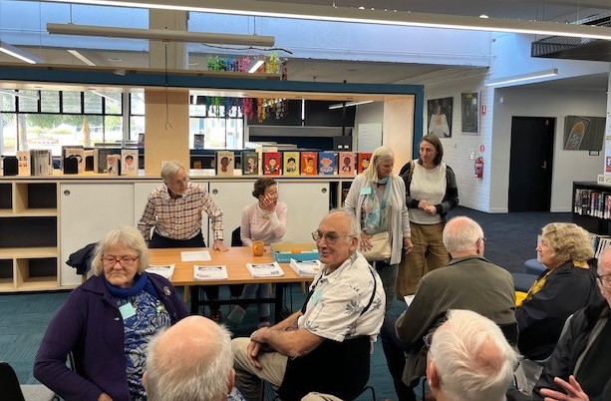
Deirdre Tolmer (Litchfield) and her daughter Miranda Tolmer arriving
Others in view, Bill Norfolk, Greta Jungwirth (de Vries), DHSESA President, Leonie Goldsmith (Smithies), Noel Goldsmith
Bill Hall, Faye Chandley (Pyke), Bernard Bolch, Robert Bluer and Ross Fotheringham
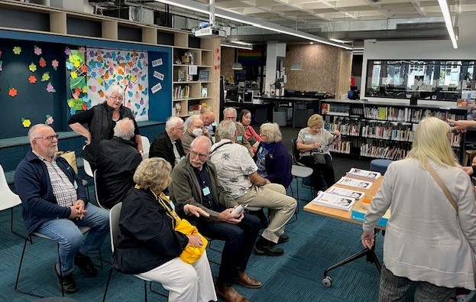
Deirdre Tolmer (Litchfield), Faye Chandley (Pyke), Bill Hall, Noel Goldsmith, Leonie Goldsmith (Smithies) and Shirley Watts (Adams)
Peter Smith, Ross Fotheringham, Yvonne Elliott (Kirkham), Robert Bluer, Bernard Bolch, John Martin, Sandra Giles (Johnston), Terry Tovey and Rosalind Terry
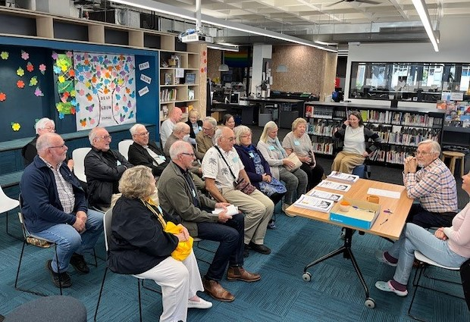
Group photo before Robert Jolly arrived, from the back
Yvonne Elliott (Kirkham), John Martin and Sandra Giles (Johnston)
Peter Smith, Ross Fotheringham, Robert Bluer, Bernard Bolch, Terry Tovey and Rosalind Terry
Faye Chandley (Pyke), Bill Hall, Noel Goldsmith, Leonie Goldsmith (Smithies), Deirdre Tolmer (Litchfield) and Shirley Watts (Adams)
Miranda Tolmer (Deirdre’s daughter), Bill Norfolk and Greta Jungwirth (de Vries), DHSESA President

Photos by Miranda Tolmer (Deirdre Tolmer (Litchfield)’s daughter, Shirley Watts (Adams) and Bill Norfolk
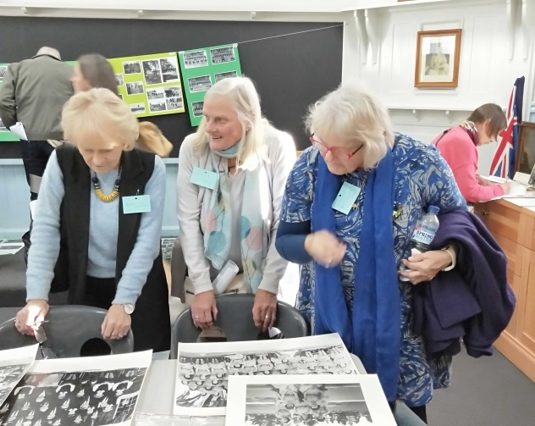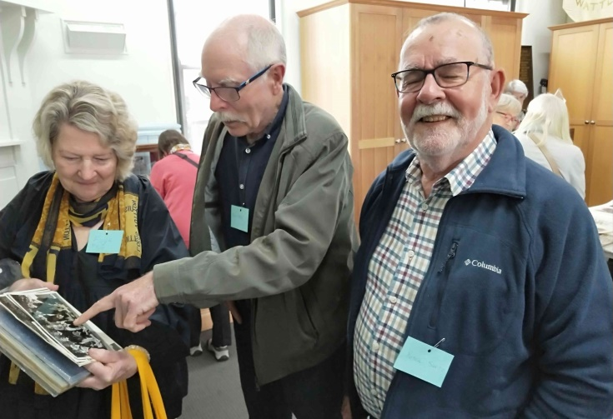
Sandra Giles (Johnston), Deirdre Tolmer (Litchfield) and Faye Chandley (Pyke), Bill Hall and Peter Smith
Leonie Goldsmith (Smithies)
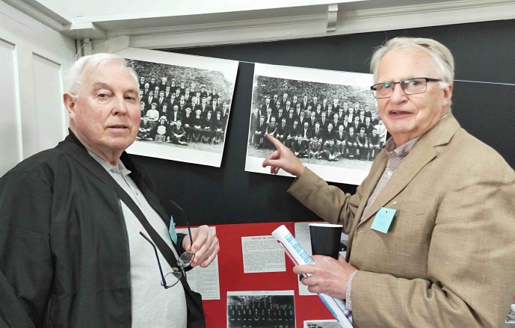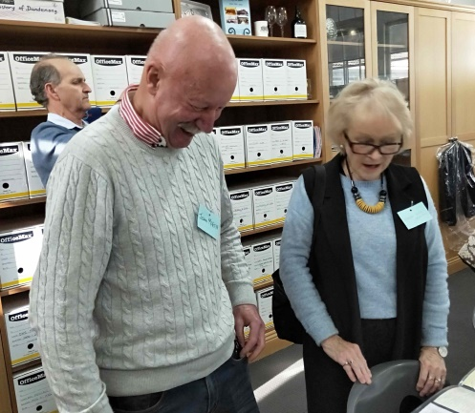
Robert Bluer and Terry Tovey John Martin and Sandra Giles (Johnston)
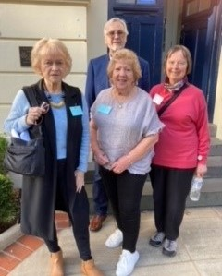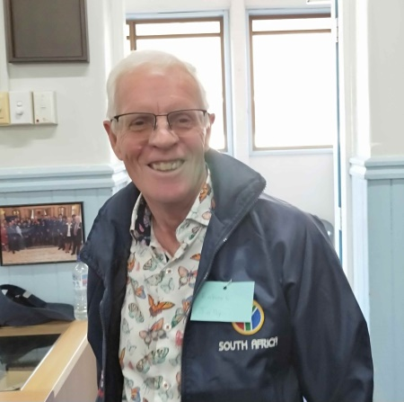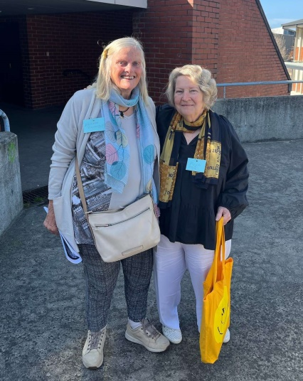
Sandra Giles (Johnston), Bill Norfolk Robert Jolly Deirdre Tolmer (Litchfield) and
Shirley Watts (Adams) and Rosalind Terry Faye Chandley (Pyke) “Fishells”
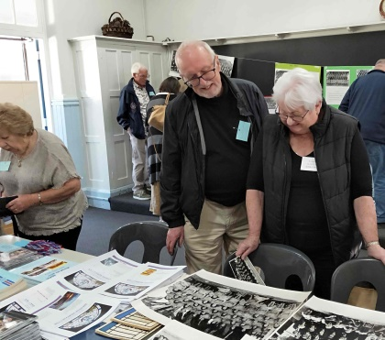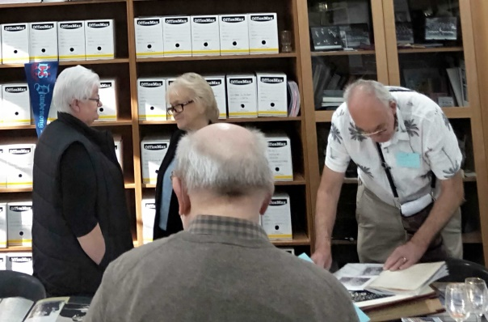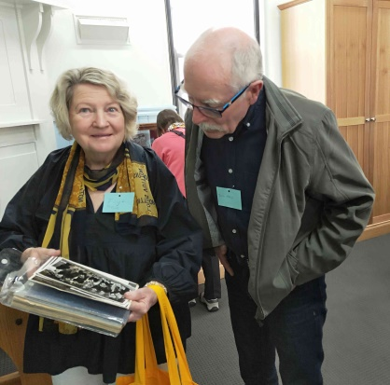
Ross Fotheringham and Yvonne Elliott (Kirkham), Sandra Giles (Johnston), Faye Chandley (Pyke) and
Yvonne Elliott (Kirkham) Noel Goldsmith and Bernard Bolch Bill Hall
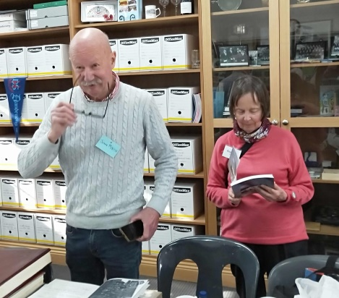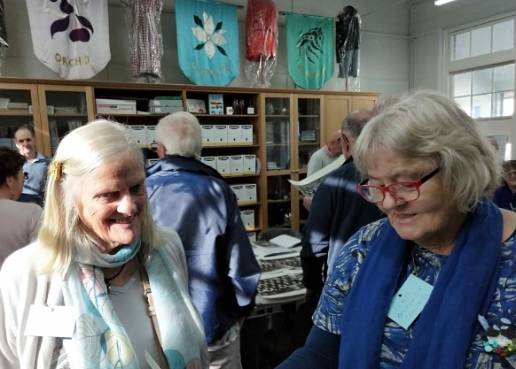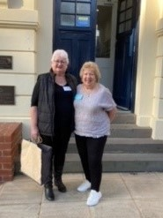
John Martin and Rosalind Terry Deirdre Tolmer (Litchfield) and Yvonne Elliott (Kirkham) and
Leonie Goldsmith (Smithies) Shirley Watts (Adams)
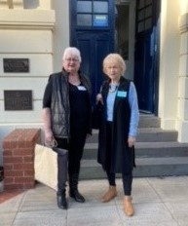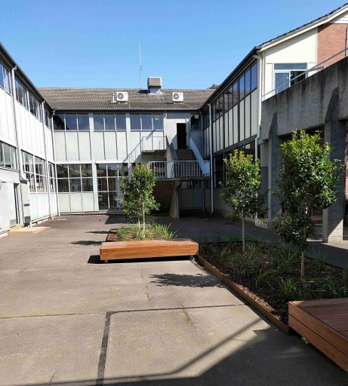
Yvonne Elliott (Kirkham) and Old School Quadrangle integrated into the new DHS
Sandra Giles (Johnston)
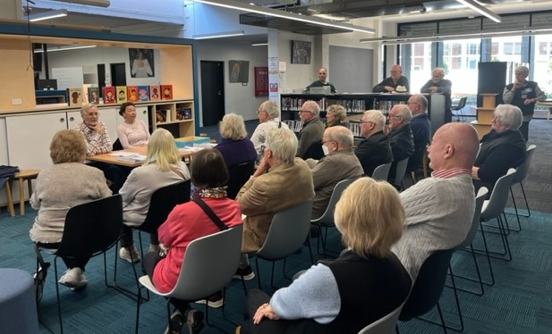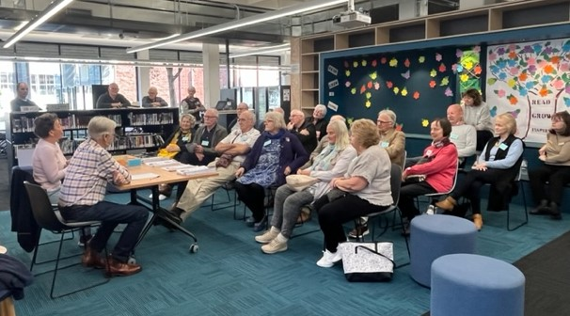
Those who attended the Class of ’63, 60 Year Reunion in the fabulous School Library and Resource Centre
before Rob Jolly was able to join us
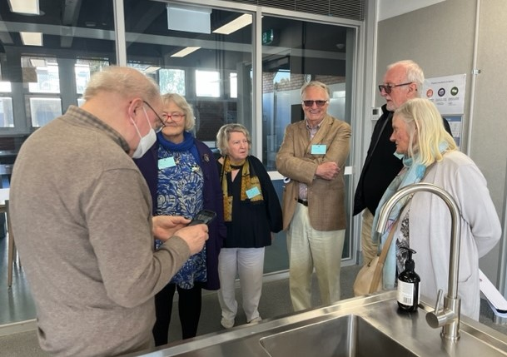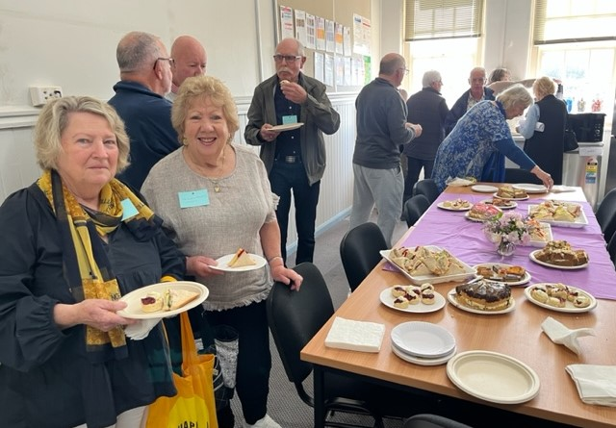
Bernard Bolch, Leonie Goldsmith (Smithies), Faye Chandley (Pyke) Faye Chandley (Pyke) and Shirley Watts (Adams) “tuck-in”
Terry Tovey, Ross Fotheringham and Deirdre Tolmer (Litchfield)
on the School tour in the new Science Block
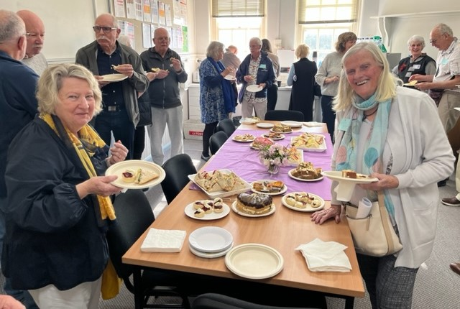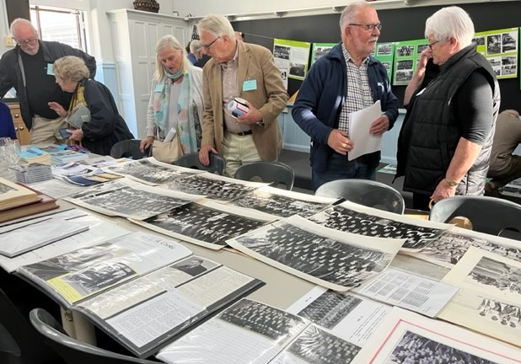
The group enjoying fine afternoon tea provided by the DHSESA Ross Fotheringham, Faye Chandley (Pyke); Deirdre Tolmer (Litchfield), Terry Tovey; Peter Smith and
Yvonne Elliott (Kirkham) discussing the DHSESA Archive
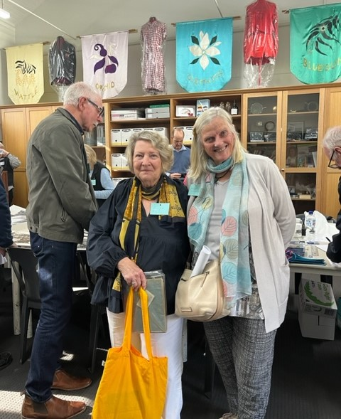
Bill Hall, Faye Chandley (Pyke) “Fishells” and Deirdre Tolmer (Litchfield)
enjoy the DHSESA Archive, with the original House Banners and school uniforms in the background

The new amalgamated Dandenong High School
Dandenong High School, Cleveland Secondary College (old Girls School) & Doveton Secondary College
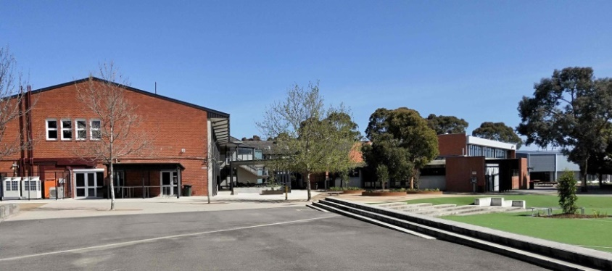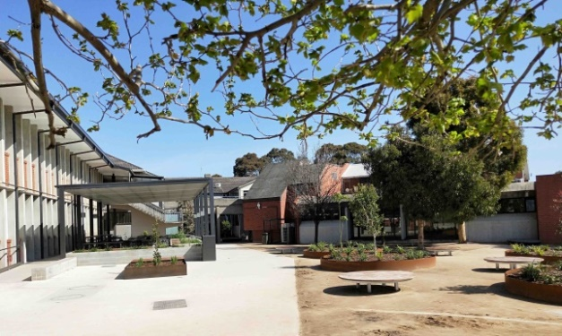
Science and Domestic Science Block, Lift and Library Cafeteria, alfresco Lunch Areaand Library
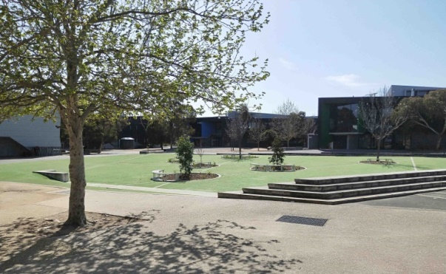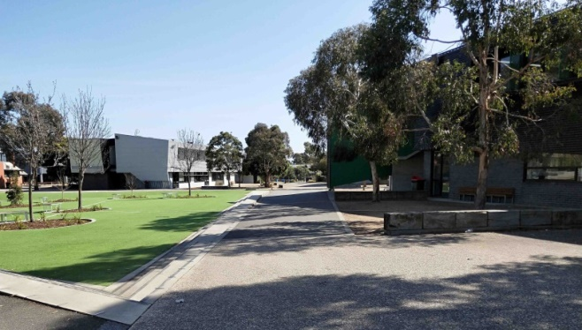
Some of the Seven House Buildings,replacing and surrounding what used to be our Oval and Sports Grounds

